**\*Contributors to the plans for this document:**

- Trieu Huu Phuong

**\*Certificate of Achievement for contributors that I designed on 04/14/2025:**

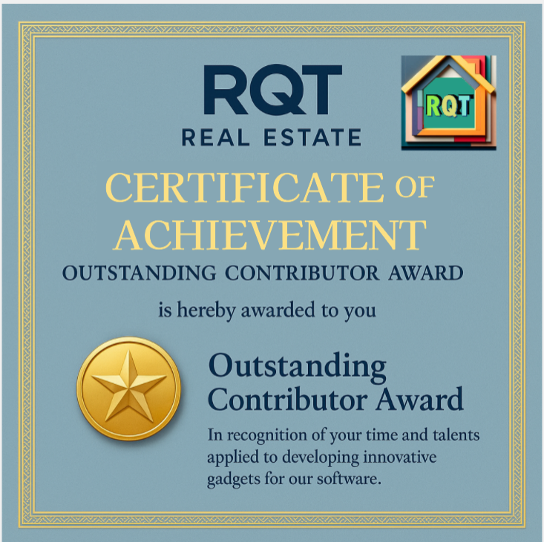

**I.Purposes/Missons:**

This certificate will be given to any contributor of this project after they complete the process of contributing anything to the project.

This certificate is placed in folder **RQT_Real_Estate\Certificates**

**Notice:**

*The original version doesn’t show any name on it, but we will redesign this certificate later to show the name of any contributor on it before we hand it to them as a reward.

*The original version can be put into any issue document on the RQT_Real_Estate repository on GitHub to let the contributor know that we will reward them with a special certificate like this

**II.Technologies that I used to design this certificate:**

ChatGPT, MS Designer

**III.The steps that I used to design this certificate:**

*Here are some of the prompts that I asked ChatGPT on 04/14/2025 to create this certificate:

I need you to create an image. I want this image looks like a Certificate of achievement for the best contributor for RQT Real Estate Project. It doesn't need to show the contributor name, but it should show some text complementing the contributor for spending time creating new gadgets for the project

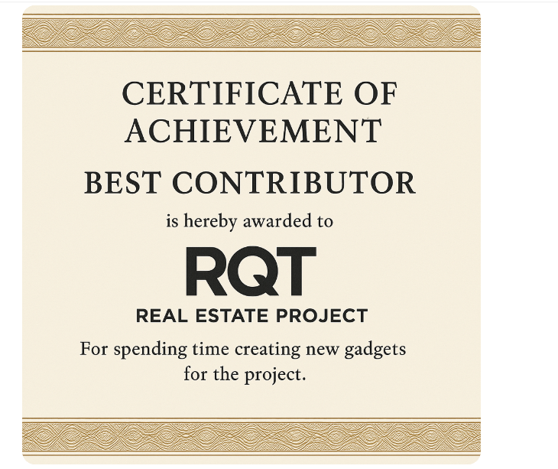

I want to adjust the content for the image above. I want the RQT REAL ESTATE to be placed above the CERTIFICATE OF ACHIEVEMENT. I want the "is hereby awarded to RQT REAL ESTATE PROJECT" to be replaced by "is hereby awarded to you". I also want to replace the text "For spending time creating new gadgets for the project" into "In recognition of your time and talents applied to developing innovative gadgets for our software."

Please change the text RQT REAL ESTATE PROJECT into RQT REAL ESTATE. Then, change the background color for me. Show me 5 examples with different background color

please add a metal award symbol into this image, and add the text "Outstanding Contributor Award" next to it too

After this, I used MS Designer to add our company logo like this onto it

Here was how this certificate looked on 04/13/2025

On 04/14/2025, I realized that the certificate showed the text “CERTIFICATE OF ACNIEVEMENT” instead of “CERTIFICATE OF ACHIEVEMENT”.

So, I have to use MS Designer and ChatGPT to adjust the text into “CERTIFICATE OF ACHIEVEMENT”.

I had to use ChatGPT to help me spot the font of the text and it showed me some fonts like:

On MS Designer, here are some steps I used to adjust the text “CERTIFICATE OF ACNIEVEMENT” to “CERTIFICATE OF ACHIEVEMENT”:

**a)I added new text**

. (I figured out this color by using this tool  Pick a color from the design-in this case just click this tool, then click the old text “CERTIFICATE OF ACNIEVEMENT”, then MS Designer will get that color)

**b)Added a new round shape**

Go to Visuals->Filled shapes

. The steps that I used to figure out this color is like the steps that I used to figure out the color for the text above with the pick a color from the design tool.

**c) Bring the text “CERTIFICATE OF ACHIEVEMENT” to the front of the square shape above.**

- I moved the text to the square shape

- Then, in the **Edit** tab, I click **Position** button from the **Text adjustments** field

* Here I selected Bring to front

**IV.The design’s final appearance on 04/14/2025:**

